Recording Method BDC:

SHDB is the T-code for recording method, go to SHDB, list of recordings will be displayed (if any), click on New Recording to create new recording.

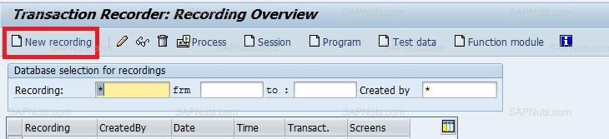

A pop up will open, provide a recording name example: ZSAPN_MM01, provide transaction code as MM01 and click recording.

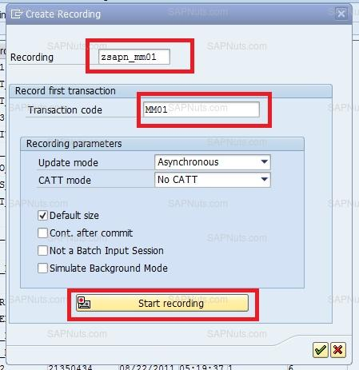

It will go to material creation screen, provide values for material creation.

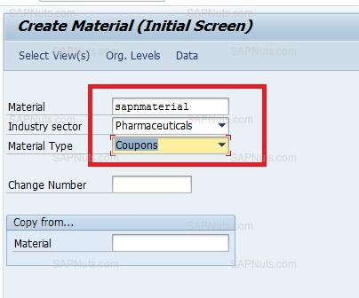

A pop up will open, select basic data1 and enter

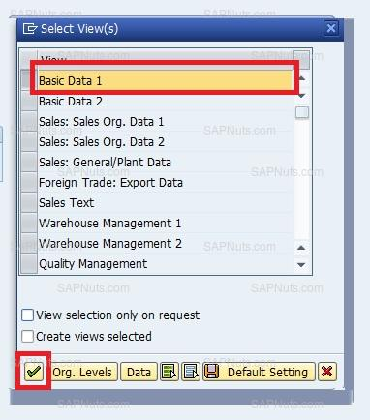

Enter below details.

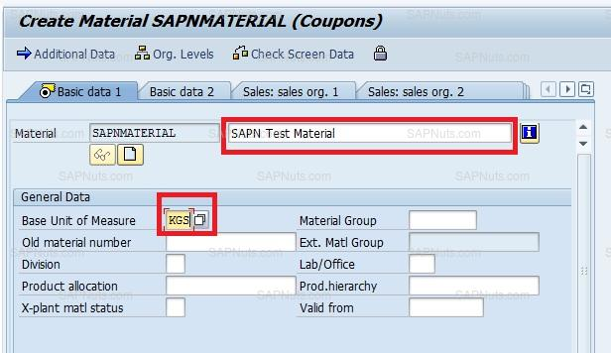

Click Save( Ctrl S), it will go to a screen with recording code.

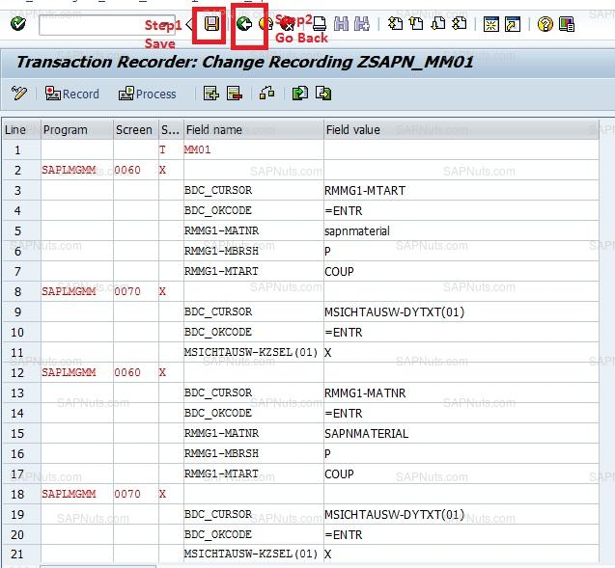

Click Save, go back, you will go to recording overview screen and click on program button to create a program for this.

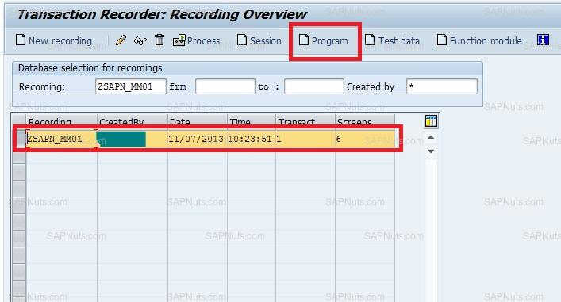

Provide a program name and enter.

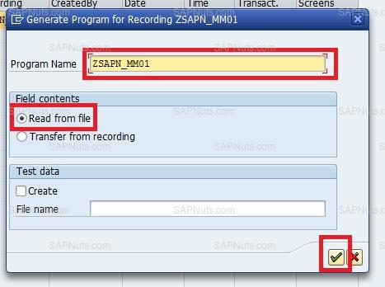

Provide title, type and click on source code.

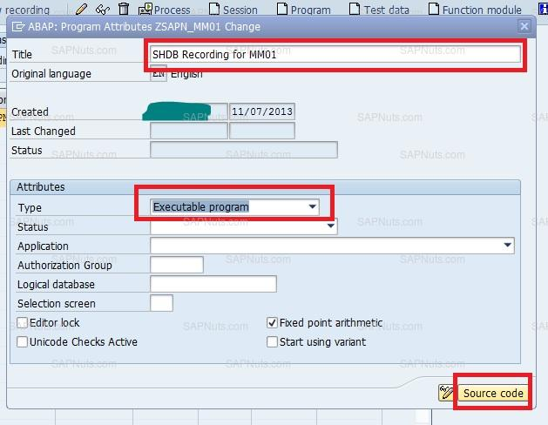

Save it in a local object, you will find the below code in the program.

Execute the program: